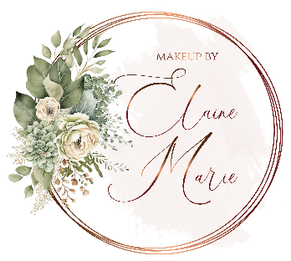

**BRIDAL SERVICE TRIAL SESSION**

Once we have had our consultation the fun really begins and we can book you in for your trial makeup session. Bridal trials usually take place around 3-4 months before your wedding and I always advise that you book one in as it is important to get the look correct at this stage and ensure that the products we select suit your skin perfectly. Sessions can take place at your home or another location depending on your preference and usually take around two hours.

During your trial, we take everything we discussed in our initial consultation and start bringing it to life. We will explore your wedding theme in more detail and this is a great opportunity for you to bring along any inspiration from magazines that you love. Many brides love to create mood boards as a way to pull together all of their ideas and this is a fun way to start the process.

We begin by discussing your favourite products and your current makeup and skincare routine. As every bride to be wants to have glowing skin on their big day we will also look at ways you can improve your current routine and I will advise you on beneficial products and treatments which will help to get your skin in tip top condition.

Once we have a clear idea of your theme and what you are trying to achieve we get to work on choosing the best products, colours and techniques to best suit your look.

I only use premium beauty ranges such as Charlotte Tilbury, Chanel, Bobbi Brown and Hourglass which have been chosen for their innovative products and staying power, perfect for bridal makeup.

Feeling good about yourself is the key to enjoying your wedding day and knowing you are looking at your absolute best is essential. I pride myself on making the bridal journey fun and relaxed from beginning to end.

In order to re-create your bridal look seamlessly, your trial session is documented and you can share with friends and family prior to the big day to get their input if you wish. We also discuss timings and makeup requirements for bridesmaids and relatives at the trial and once your booking is confirmed, I will send you a schedule to ensure everything runs smoothly on the day.

**THE DETAILS**

Your make-up will take around 1 hour 15 minutes and I allow 30- 45 minutes for each member of the bridal party.

I will ensure there is adequate time (usually around an hour) after we have completed your make-up and your hair is also done, so that you can get into your dress, breath and relax before you have your first photographs of the day taken.

Minimum booking requirement of Bride plus 3 bridal party members, for Friday, Saturday and Sunday weddings. Additional members of the bridal party can be extended to include extra Bridesmaids, Mother of the Bride and Groom.